GAME DESIGN SPECIFICATION

MEDIAN

Civilization Spatial Design
  - Mouse Manor House / Rabbit Cul-de-Sac / Squirrel Web
Status: Concept Spec • Scope: Tiered base form within the Median Reach • Tone: Sentimental base-builder

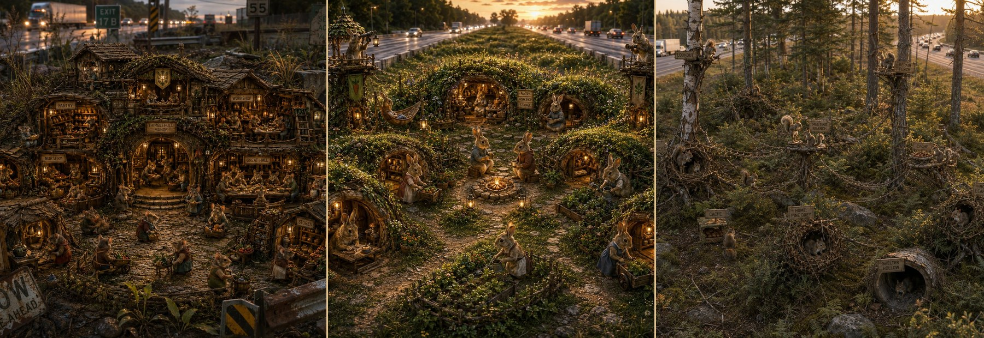
Concept-art studies used as spatial references. Final production art must preserve the settlement grammar even when terrain, climate, and highway form change.

1. Purpose and Core Decision
This specification defines how Mouse, Rabbit, and Squirrel civilizations occupy the same Median Reach using the same basic construction economy while producing unmistakably different settlements. The distinction is spatial and emotional, not statistical.
CORE PROPOSITION
Mouse builds a Manor House. Rabbit builds a Cul-de-Sac. Squirrel builds a Web.

The player should be able to identify the civilization from the shape of the base before seeing the inhabitants. The design must not depend on small percentage bonuses, dense service-radius overlays, or production-chain optimization. Each species is defined by one clear placement verb:
MOUSE | RABBIT | SQUIRREL
JOIN | GATHER | CONNECT

Design Goals
- One common building grammar, three visibly different settlement outcomes.
- Placement choices that can be understood by looking at the world, not by reading modifiers.
- Expansion that creates new relationships and small stories rather than merely increasing output.
- A strong connection to the physical Median Reach: roads, shoulders, barriers, drainage, vegetation, and isolated habitat.
- A base the player becomes attached to because individual lives visibly inhabit the spaces between buildings.

Non-Goals
- Three separate economy simulations.
- Species balance through many small numeric bonuses and penalties.
- Cosmetic reskins of one generic village layout.
- A city-builder population scale in which individual residents disappear into abstraction.

2. The Median Reach as the Shared Territory
All three civilizations develop the same broad territory. Species changes how the Reach is inhabited, not the fundamental world structure.
Territory band | Design role
Median Interior | Sovereign home territory. Permanent domestic and civic construction occurs here.
Shoulder Strip | Exposed raid territory. It may contain staging points or temporary nodes, but it does not become ordinary residential land.
Carriageway Gap | The dangerous threshold separating one Median Reach from the next. Crossing it is a major expansion event.
Chain of Median Strips | The larger progression space. Each new median receives a new local expression of the chosen civilization grammar.

REACH-LEVEL RULE
A Reach contains one Mouse estate, several Rabbit courts, or one Squirrel web. Crossing the carriageway does not merely extend the old base; it founds a new local settlement.

3. Civilization Spatial Grammar
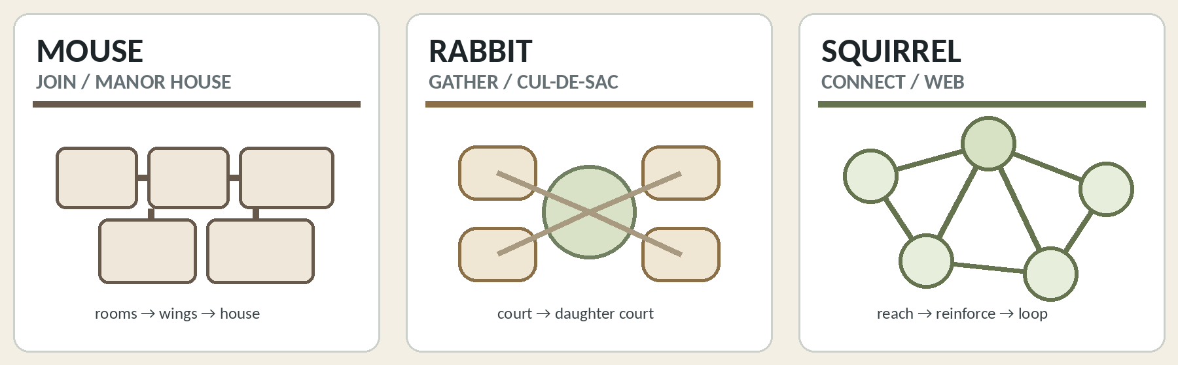
The three base silhouettes: connected mass, neighborhood cells, and distributed network.
MOUSE — Manor House | JOIN

The Mouse colony is one increasingly elaborate inhabited structure. Buildings behave as rooms, additions, wings, and connected houses. The emotional fantasy is not “a town of mice,” but a humble dwelling gradually becoming a storied household and estate.

Primary placement rule
PLACE BY ATTACHMENT
A new Mouse unit must join the existing structure. Placement automatically creates a shared wall, doorway, stair, covered passage, or other protected connection.

- Homes and civic rooms accumulate into one coherent body.
- The player’s eye moves into the structure: doors, rooms, passages, shared warmth, and accumulated domestic history.
- A site may be subterranean, overground, inside highway debris, or built against a barrier; the identity remains the connected Manor House.
- The base becomes denser and richer before it becomes geographically broader.

Expansion rhythm
- Room: add one needed function to the existing household.
- Wing: a chain of rooms develops a distinct purpose or family identity.
- Second House: when the Manor becomes unwieldy, establish another connected household within the Reach.
- New Reach: crossing the carriageway founds a new Manor, not another wing of the old one.

Emotional failure state
The Manor is vulnerable as one beloved body. A breach, flood, fire, or collapse threatens connected rooms and remembered places. The story is domestic: the house itself has a history worth saving.
RABBIT — Cul-de-Sac | GATHER

The Rabbit colony is a neighborhood of burrows gathered around shared open ground. Individual homes matter, but the civilization is created by the protected space between them: the green, court, play area, meeting circle, and familiar daily frontage.

Primary placement rule
PLACE AROUND A CENTER
A Rabbit unit must face or help define a shared court. The court is emergent negative space, not a purchased building.

- Buildings turn inward toward neighbors rather than joining into a single mass.
- The player’s eye moves around the shared green: doors, paths, kits, meals, grooming, and public life.
- Each court remains small enough to feel like a recognizable neighborhood.
- Open ground is not unused land. It is the social heart and the reason the settlement feels Rabbit.

Expansion rhythm
- Complete one court: enough homes and shared functions gather around a safe center.
- Bud a daughter court: extend a short lane into another suitable patch of the Median Interior.
- Connect courts: paths lead to larger shared facilities or a Great Green without erasing neighborhood identity.
- New Reach: the crossing party establishes the first court of a daughter Warren.

Emotional failure state
A court becomes overfull or exposed. The answer is not to squeeze in another door, but to make a new place for a new group of neighbors. Rabbit expansion is the story of communities budding from communities.
SQUIRREL — Web | CONNECT

The Squirrel colony is a constellation of separated homes, caches, refuges, lookouts, and meeting nodes held together by traversable routes. No single building contains the civilization. The emotional fantasy is belonging at a distance: everyone has a place of their own, yet no one is alone.

Primary placement rule
PLACE APART, THEN CONNECT
A Squirrel node must be separated from other domiciles and joined to the web by a credible route. One connection makes an outpost; a second way home makes it part of the civilization.

- Homes do not cluster into apartments or a centralized treehouse village.
- The player’s eye moves along lines between distinct anchors: tree, shrub, sign support, fence, culvert crown, snag, or sound-wall structure.
- Routes must cross real gaps and lead somewhere meaningful. Decorative ropes around one large building do not create a web.
- Storage, shelter, observation, and meeting functions remain distributed.

Expansion rhythm
- Reach: establish a useful distant node beyond the current web.
- Reinforce: add an alternate route, intermediate refuge, cache, or cross-link.
- Thicken: convert a fragile branch into a loop or mesh with another way home.
- New Reach: establish an anchor beyond the carriageway, then grow a new local web rather than one continuous everyday route across traffic.

Emotional failure state
A route breaks and someone is cut off. Repair is not an abstract throughput task; it is the restoration of a relationship. The web stretches, then learns to hold.

4. Shared Construction System
Recommendation: six universal building functions, with Nursery as an optional seventh. Each equivalent unit has the same cost, build time, nominal footprint, and broad capacity. Species identity comes from name, form, placement, and resident behavior.
NO STATS-TWEAKER LAYER
Avoid adjacency percentages, overlapping service radii, and fine-grained efficiency tuning. Placement is valid, evocative, and visibly inhabited—or it is gently rejected with an in-world explanation.

Shared function | Mouse manifestation | Rabbit manifestation | Squirrel manifestation
Home | Bedchamber / Nest Room | Family Burrow | Drey
Pantry | Store Room | Common Store | Cache
Workshop | Workroom | Work Yard | Repair Perch
Gathering | Great Hall / Hearth Hall | Commons | Meeting Branch
Care | Warm Room / Infirmary | Healing Burrow | Shelter Hollow
Watch | Gatehouse / Listening Post | Sentry Rise | Lookout Crown
Optional Nursery | Nursery Room | Kit Burrow | Nursery Drey

One placement relationship per species
Function | Mouse | Rabbit | Squirrel
Home | Attach to the Manor | Face the court | Separate and connect
Pantry | Inside the house | Near the shared center | Scatter along the web
Workshop | Join the working wing | Open onto path or yard | Place beside what it repairs
Gathering | At the interior heart | The shared open center | At a route junction
Care | Protected within the house | Near homes, away from bustle | Between distant households
Watch | At an entrance | At the outer edge | High and connected
Nursery | Attached to family rooms | Facing a safe court | Separate, with two ways home

Abstract size versus visible size
Equal footprint means one equivalent build unit in the construction system; it does not require identical visible bulk. A Squirrel Drey may be physically small while claiming the spacing and route position needed for one household. A Rabbit Commons may be mostly open ground. A Mouse room may use almost the full footprint as enclosed interior.

5. Expansion Inside One Median Reach
Civilization | Expansion sequence | Resulting Reach
Mouse | Another room → another wing → another connected house | The estate thickens around the original household. The Reach feels increasingly drawn into one protected interior.
Rabbit | Complete court → bud another cul-de-sac → connect courts | The Warren grows as recognizable neighborhoods separated by useful open ground.
Squirrel | Extend one strand → add a second route → form loops | The Den gains distance first, then resilience and belonging through thickness.

How the base tells the player it is ready to expand
MOUSE FULLNESS
The household visibly crowds: circulation becomes busy and the next addition wants to become a distinct wing or second house.

RABBIT FULLNESS
The court feels complete: every side is lived-in and another entrance would diminish the shared green.

SQUIRREL NEED
The web reveals either unreached terrain or a fragile single strand. The player chooses distance or thickness rather than filling a district.

Species-level emotional promise
MOUSE | “There is room for you under our roof.”
RABBIT | “We will make another neighborhood for you.”
SQUIRREL | “We will bring you into reach.”

6. Shoulder Territory and Inter-Median Expansion
The Shoulder Strip remains exposed raid territory for all species. Civilization may touch it, observe it, stage from it, or temporarily exploit it, but permanent domestic form stays inside the Median Interior.
Species | Allowed frontier expression | Readable pattern
Mouse | A controlled door at the edge: staging room, concealed entrance, return pantry, or listening point. | Interior mass → narrow portal → raid → return inside.
Rabbit | A guarded lane beyond the last court: sentry point, muster area, temporary forage access, or bolt refuge. | Court → lane → watched edge → communal excursion → return.
Squirrel | A thin operational extension: lookout, relay, cache, harvest perch, or weather refuge—never a dense residential center. | Web → frontier node → relay or return.

Crossing the Carriageway Gap
MOUSE — FOUND A NEW MANOR
The new Median Interior begins as a daughter house. The old estate remains the Old House; the crossing creates lineage, not a physically continuous wing.

RABBIT — FOUND THE FIRST NEW COURT
The crossing party establishes a small shared green and the first burrows of a daughter Warren. New courts can later bud from it.

SQUIRREL — CAST AN ANCHOR, THEN WEAVE LOCALLY
A refuge, lookout, or cache establishes presence. A new local web develops around it. The carriageway remains an exceptional crossing, not an ordinary daily strand.

7. Sentimental Base-Builder Feedback
The primary reward is not a larger number. It is the moment when placement creates a visible relationship and a small life begins there.
MOUSE
A new doorway opens; neighbors carry a meal through it; the addition acquires family objects and signs of use.

RABBIT
Burrows complete a court; kits begin playing in the middle; adults greet one another across the green.

SQUIRREL
A new route is crossed for the first time; the distant resident is welcomed; a second connection changes an outpost into home.

Interface language
The game should describe animal preferences rather than expose a calculation. Construction feedback is short, warm, and concrete.
Situation | Player-facing line
Mouse invalid | “This room needs to join the house.”
Rabbit invalid | “A burrow needs a court to face.”
Squirrel invalid | “Too close for another family.” / “This home needs a way back to the web.”
Squirrel completion | “There is another way home now.”

Resident scale
Populations should remain small enough that the player recognizes households and routes. A settlement is successful when the player remembers who lives in a wing, around a court, or at the far end of a strand. Tier growth may add residents, but it must not erase the household-scale fiction.

8. Visual Readability and Art Direction
Species | Must read as | Avoid
Mouse | The eye moves into a coherent structure. One roofline or protected body; visible rooms, annexes, passages, and accumulated repair. | Do not fragment the Manor into a Rabbit-like village of separate cottages.
Rabbit | The eye moves around one or more shared greens. Burrow entrances face inward; open ground is active and socially inhabited. | Do not turn the Warren into a dense apartment block or one central building.
Squirrel | The eye follows routes between separated anchors. Homes and civic nodes occupy different trees, shrubs, signs, snags, or structures. | Do not use a dollhouse cutaway, central pantry, or one “treehouse headquarters” containing the whole civilization.

Terrain variation
Highway form and median ecology should vary widely—urban sound walls, wet divided highways, dry sagebrush, Maine woodland medians, culverts, guardrails, signage, barriers, and partial copses. Terrain variation must reskin the opportunity space without erasing the civilization silhouette.

The single-frame test
MOUSE
“Look how much house we have made.”

RABBIT
“Look at everyone living around the green.”

SQUIRREL
“Look how far the network reaches—and how many ways lead home.”

9. Elements That Should Not Be Forced into the Identical-Building Lens
The universal building set should remain strict, but each civilization needs one connective spatial element that is not itself another priced room.
MOUSE CONNECTIVE INTERIOR
Doors, passages, stairs, covered links, and short tunnels appear as the consequence of attachment. They are connective tissue, not a separate optimization network.

RABBIT COURT / GREEN
The shared center is emergent negative space defined by surrounding placement. It should not be purchased as a decorative tile.

SQUIRREL ROUTES
Routes are the visible substance of the web and require simple player authorship or approval. They are not a reskinned building and should cross meaningful gaps between nodes.

NEW-REACH FOUNDING
Crossing a carriageway is a progression event, not routine local construction. The new median begins a new Manor, Court, or Web.

ADVANCED SIGNATURE PROJECTS
Late tiers may introduce a few civilization-specific landmarks, but they must grow from the core grammar rather than replacing it with a new stats layer.

10. Minimal Implementation Rules
THE SMALLEST VIABLE SYSTEM
One shared build menu. One species-specific placement rule. One species-specific connective visual. One expansion rhythm. One set of sentimental resident animations.

1 | Select one universal function: Home, Pantry, Workshop, Gathering, Care, Watch, or optional Nursery.
2 | Pay the same cost and place the same abstract-size unit regardless of species.
3 | Validate placement using the civilization verb: Join, Gather, or Connect.
4 | Generate the connective consequence: protected attachment, shared court, or traversable route.
5 | Trigger a resident animation that demonstrates why the placement matters.
6 | Use the completed local pattern to prompt expansion: wing, daughter court, or reach-and-reinforce.
7 | Reserve the Shoulder for raids and treat a new median as a founding event.

Acceptance criteria
- A screenshot with inhabitants hidden still reads as Mouse, Rabbit, or Squirrel.
- The player can state the placement rule after placing two or three buildings.
- The player is rewarded by visible life and relationship, not chiefly by efficiency text.
- A new district or Reach feels like a meaningful founding event.
- Changing highway biome changes the scenery and opportunities without turning the civilization into a generic village.
FINAL DESIGN STATEMENT
Mouse builds rooms. Rabbit builds neighbors. Squirrel builds connections.

Visual Reference A — Mouse Manor House
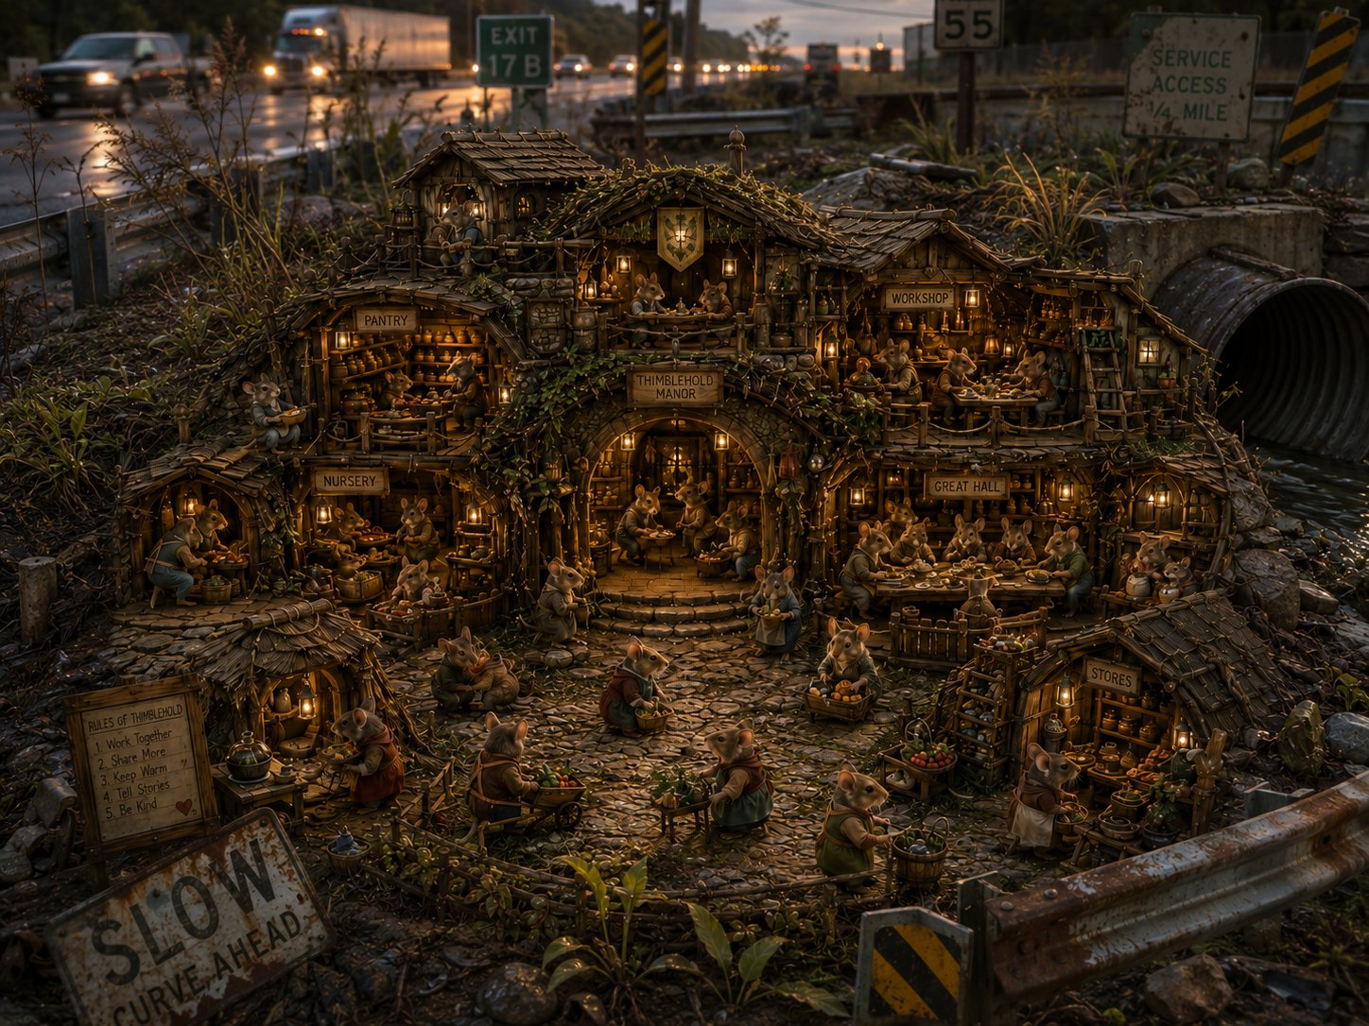
A dense, singular estate set directly in highway infrastructure. The useful reference is the coherent building body; future art should reduce any Rabbit-like open village frontage.
- Strong: one protected structure, specialized rooms, accumulated domestic density.
- Preserve: improvised roadside materials and visibly inhabited interior relationships.
- Watch: avoid separate cottage composition or a court that becomes the visual center.

Visual Reference B — Rabbit Warren
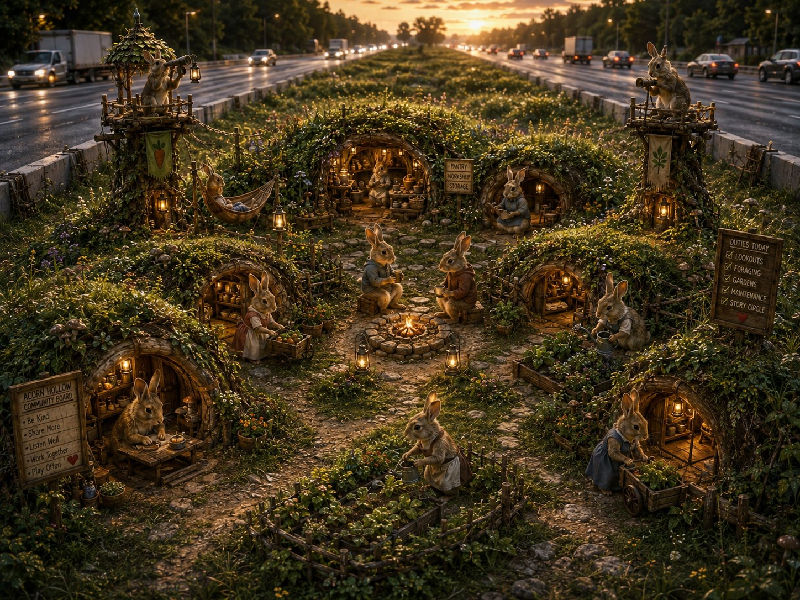
A small population arranged around shared open ground inside a highway median. The court is the social center and the burrows face it.
- Strong: cul-de-sac frontage, central shared life, low communal scale.
- Preserve: open green as active space rather than empty scenery.
- Watch: new growth should bud another court rather than thicken this one indefinitely.

Visual Reference C — Squirrel Web in a Maine Median
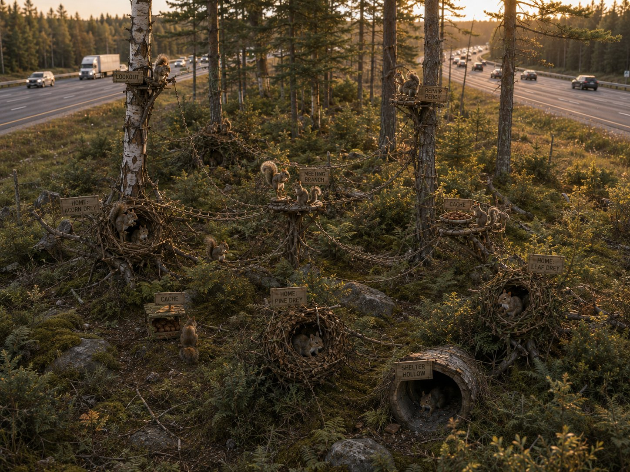
Separated domiciles and civic nodes spread through a partial copse, linked by routes that cross real gaps.
- Strong: multiple natural anchors, visible distance, no central headquarters.
- Preserve: routes as the primary compositional lines and the sense that the network continues beyond frame.
- Watch: avoid centralized rooms, oversized communal buildings, or decorative ropes that do not connect distinct places.

Appendix — One-Page Civilization Reference
Question | Mouse | Rabbit | Squirrel
Core shape | Manor House | Cul-de-Sac | Web
Verb | Join | Gather | Connect
Basic placement | Touch the existing house | Face a shared court | Stay apart and join the route network
Local expansion | Another room or wing | Another nearby court | More distance, then more thickness
Reach completion | One estate with connected houses | Several courts linked by lanes | Important nodes linked by loops
Shoulder use | Controlled raid portal | Guarded frontier lane | Temporary thin node
New median | New Manor | First new Court | Anchor and new local Web
Emotional promise | Room under our roof | A neighborhood for you | You are within reach
Visual failure | Generic village cottages | Dense central building | Mouse dwelling with squirrels in it
END OF SPECIFICATION

